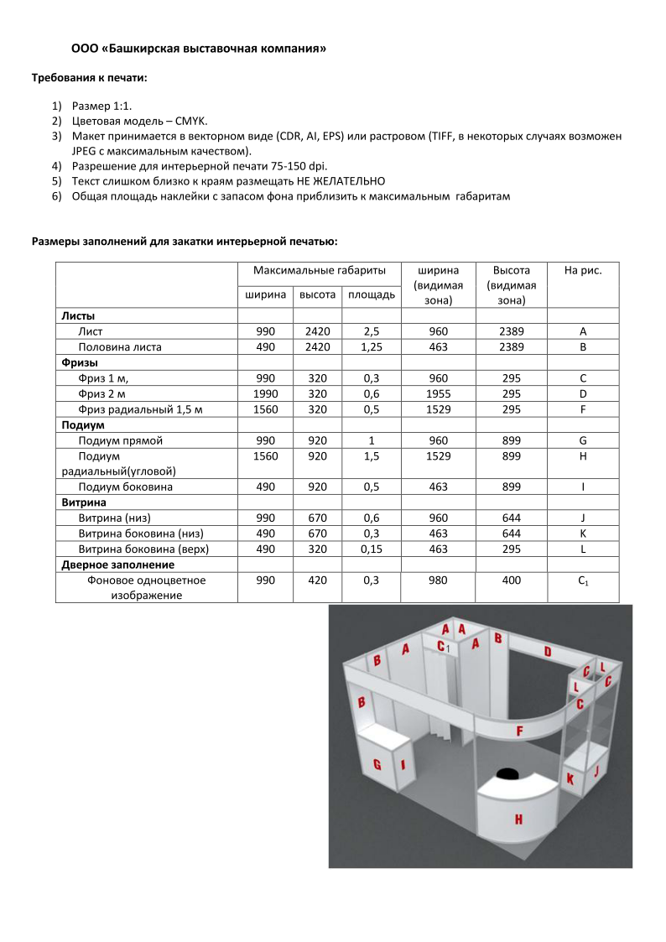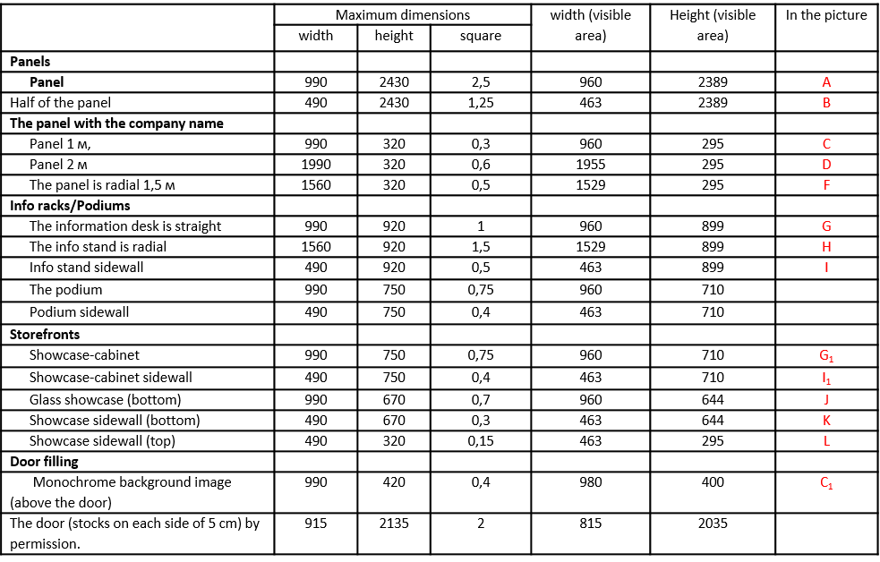

**П3/1**

**The deadline for submission is: February 26, Send by mail: agro@bvkexpo.ru**

PRINTING REQUIREMENTS

**Attention. Design layouts of banners and other advertising and information materials (ROME) are provided by the customer.**

**It is necessary to provide a scheme for pasting the stand (which layout to glue on which panel).**

Technical requirements for layouts:

Size 1:1Color model – CMYKThe layout is accepted in vector form (CDR, AL, EPS) or raster (TIFF, in some cases JPEG with maximum quality is possible).The resolution for interior printing is 75-150 dpi.It is NOT ADVISABLE to place the text too close to the edges.The total area of the sticker with a background margin should be brought closer to the maximum dimensions.

**Sizes of fillings for interior printing:**